Lab 1

Name =Rachappa

SRN = pes1UG19CS359

ROLL NO - 1

Implementation of ARM7TDMI-ISA to Block transfer of

data items

; this code copy an array from one address from other memory address .

; Implementation of ARM7TDMI-ISA to Block transfer of

;data items

.TEXT

LDR R0, =A

LDR R1, =B

MOV R3, #5

LDR R5,=B;

LOOP:

LDR R2, [R0]

STR R2, [R1]

ADD R0, R0, #4

ADD R1, R1, #4

SUBS R3, R3, #1

BNE LOOP

MOV R3, #5

LOOP1:

LDR R2, [R5]

ADD R5, R5, #4

SUBS R3, R3, #1

BNE LOOP1

SWI 0X011

.DATA

A: .WORD 1, 2, 3, 4, 5

B: .WORD 0

OUTPUT

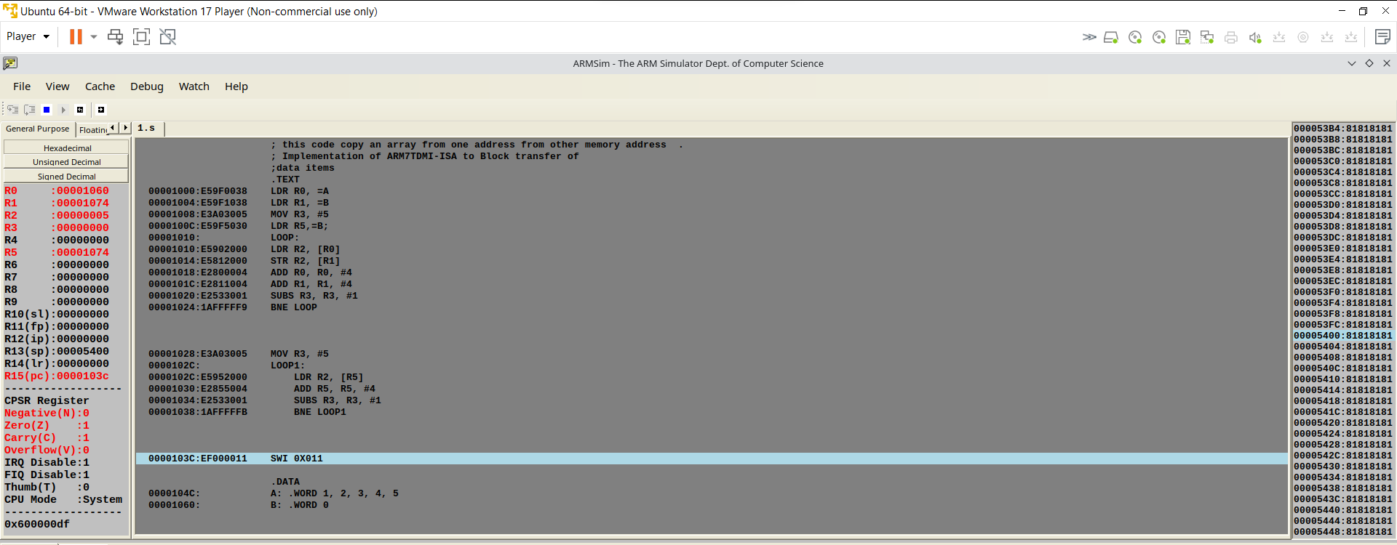

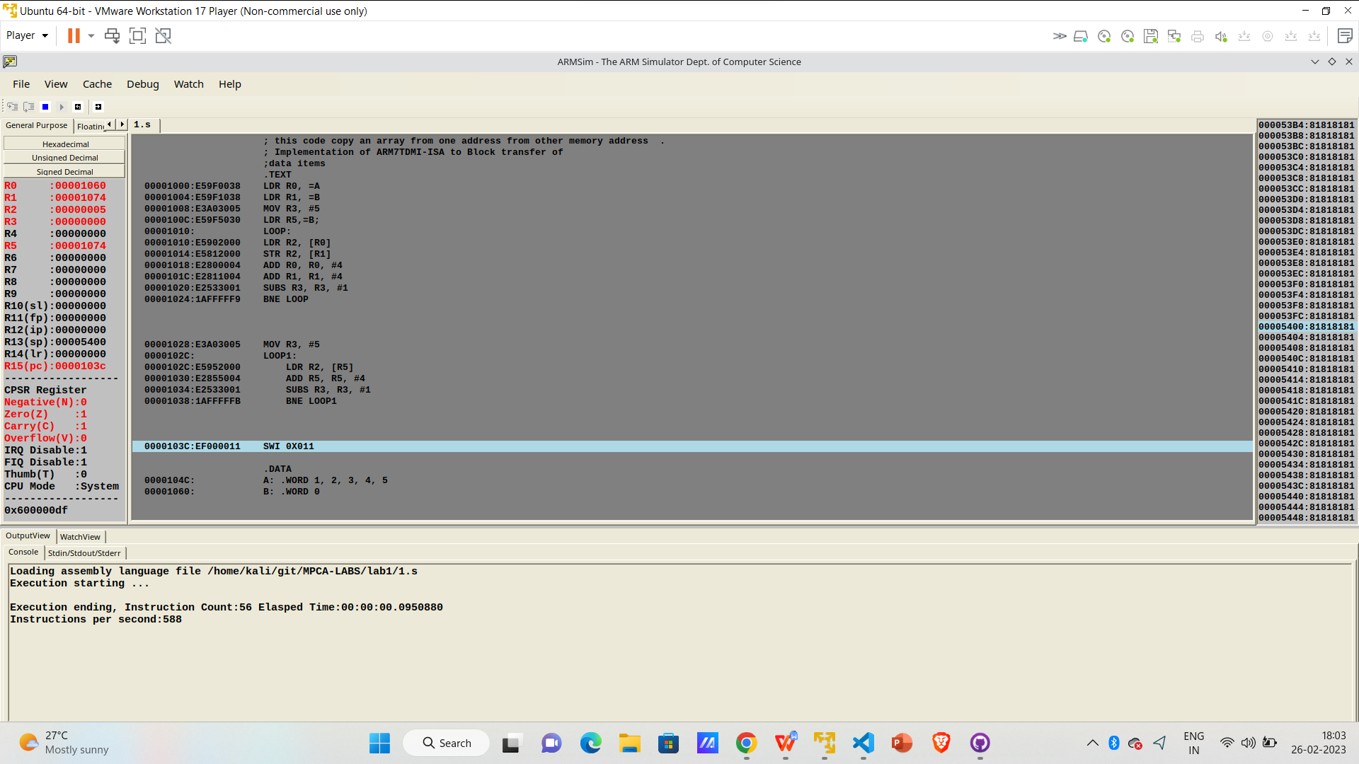

2. Find sum of N data items in

the memory.

.data

A:.WORD 10,20,30,40,50,60,70,80,90,11

.text

LDR R0,=A

MOV R1,#10

MOV R3,#0

LOOP:CMP R1,#0

BEQ EXIT

LDR R2,[R0],#4

ADD R3,R3,R2

SUB R1,R1,#1

B LOOP

EXIT:SWI 0x11

.end

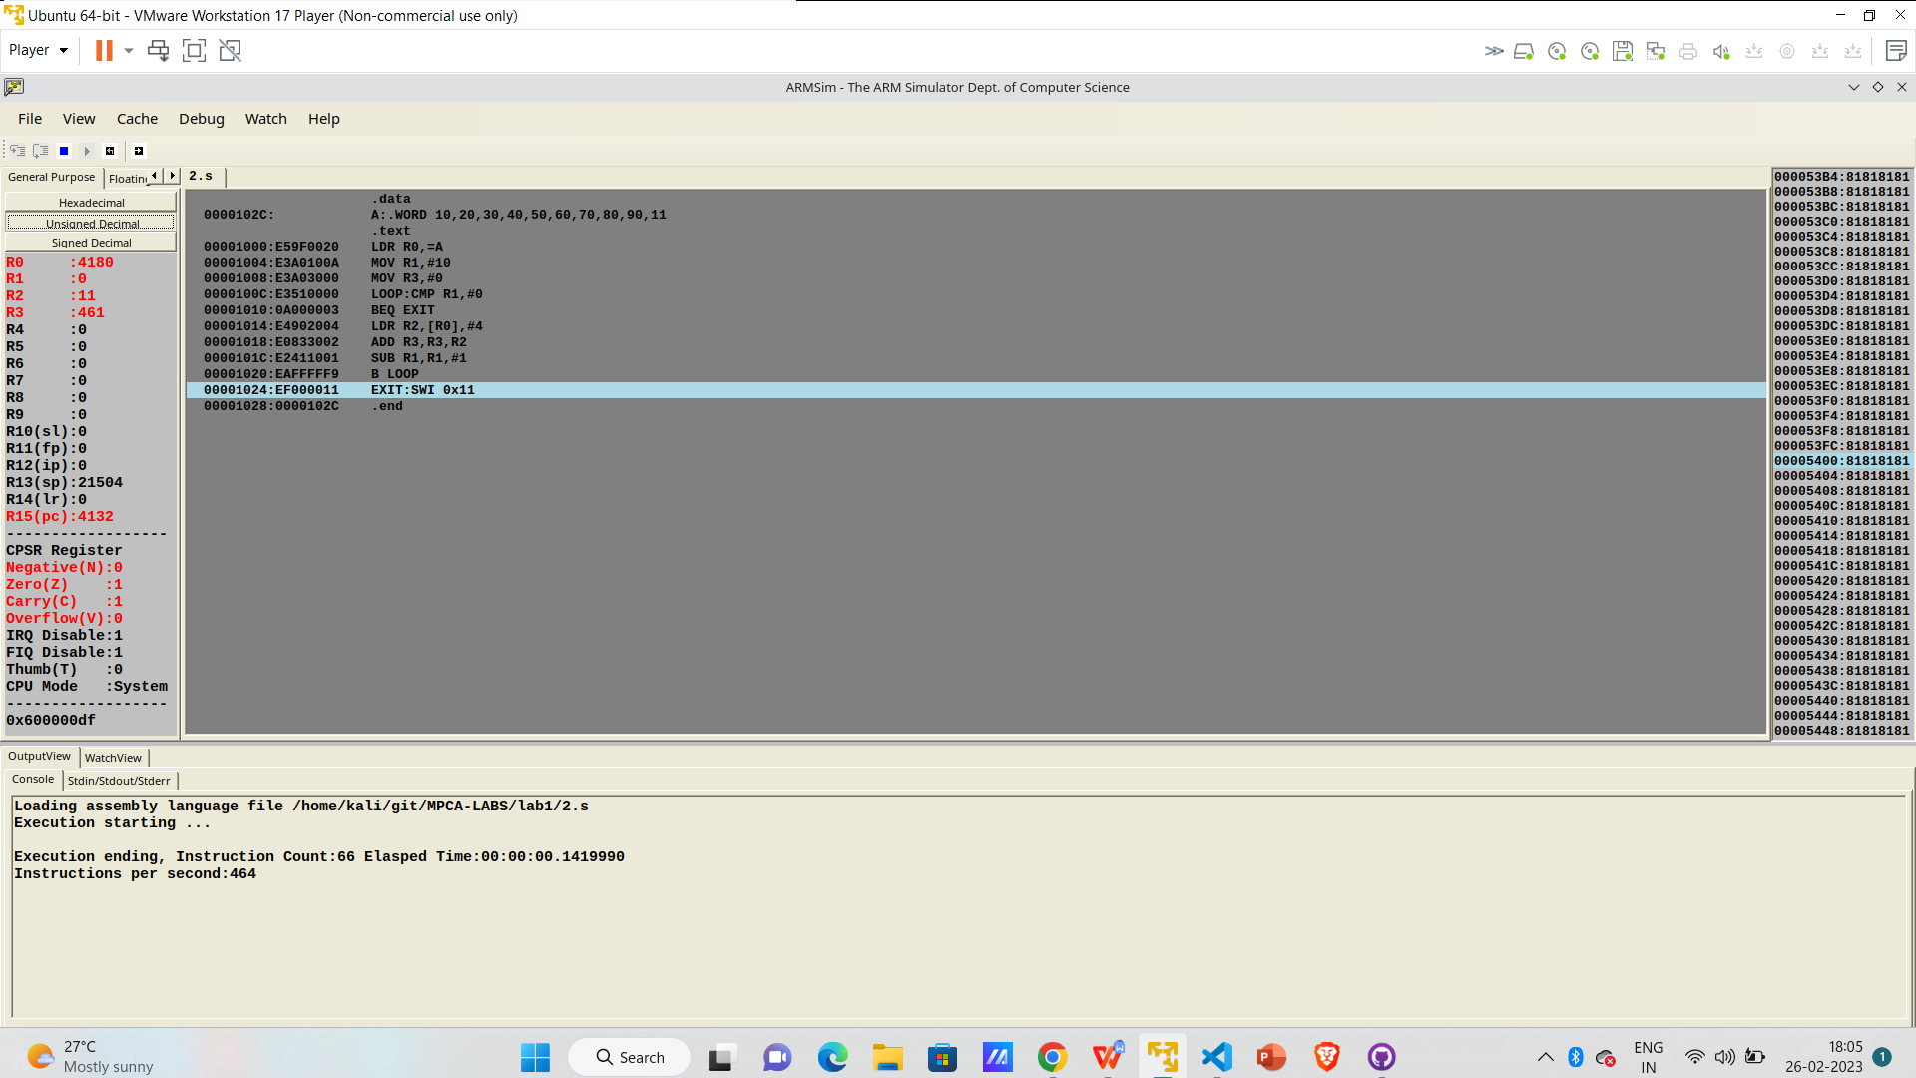

[\\\\\\](\\\\)

1. Find Factorial

.text

MOV R0,#5

MOV R1,#5

LOOP:SUB R0,R0,#1

MUL R2,R1,R0

MOV R1,R2

CMP R0,#1

BEQ EXIT

B LOOP

EXIT:SWI 0x11

.end

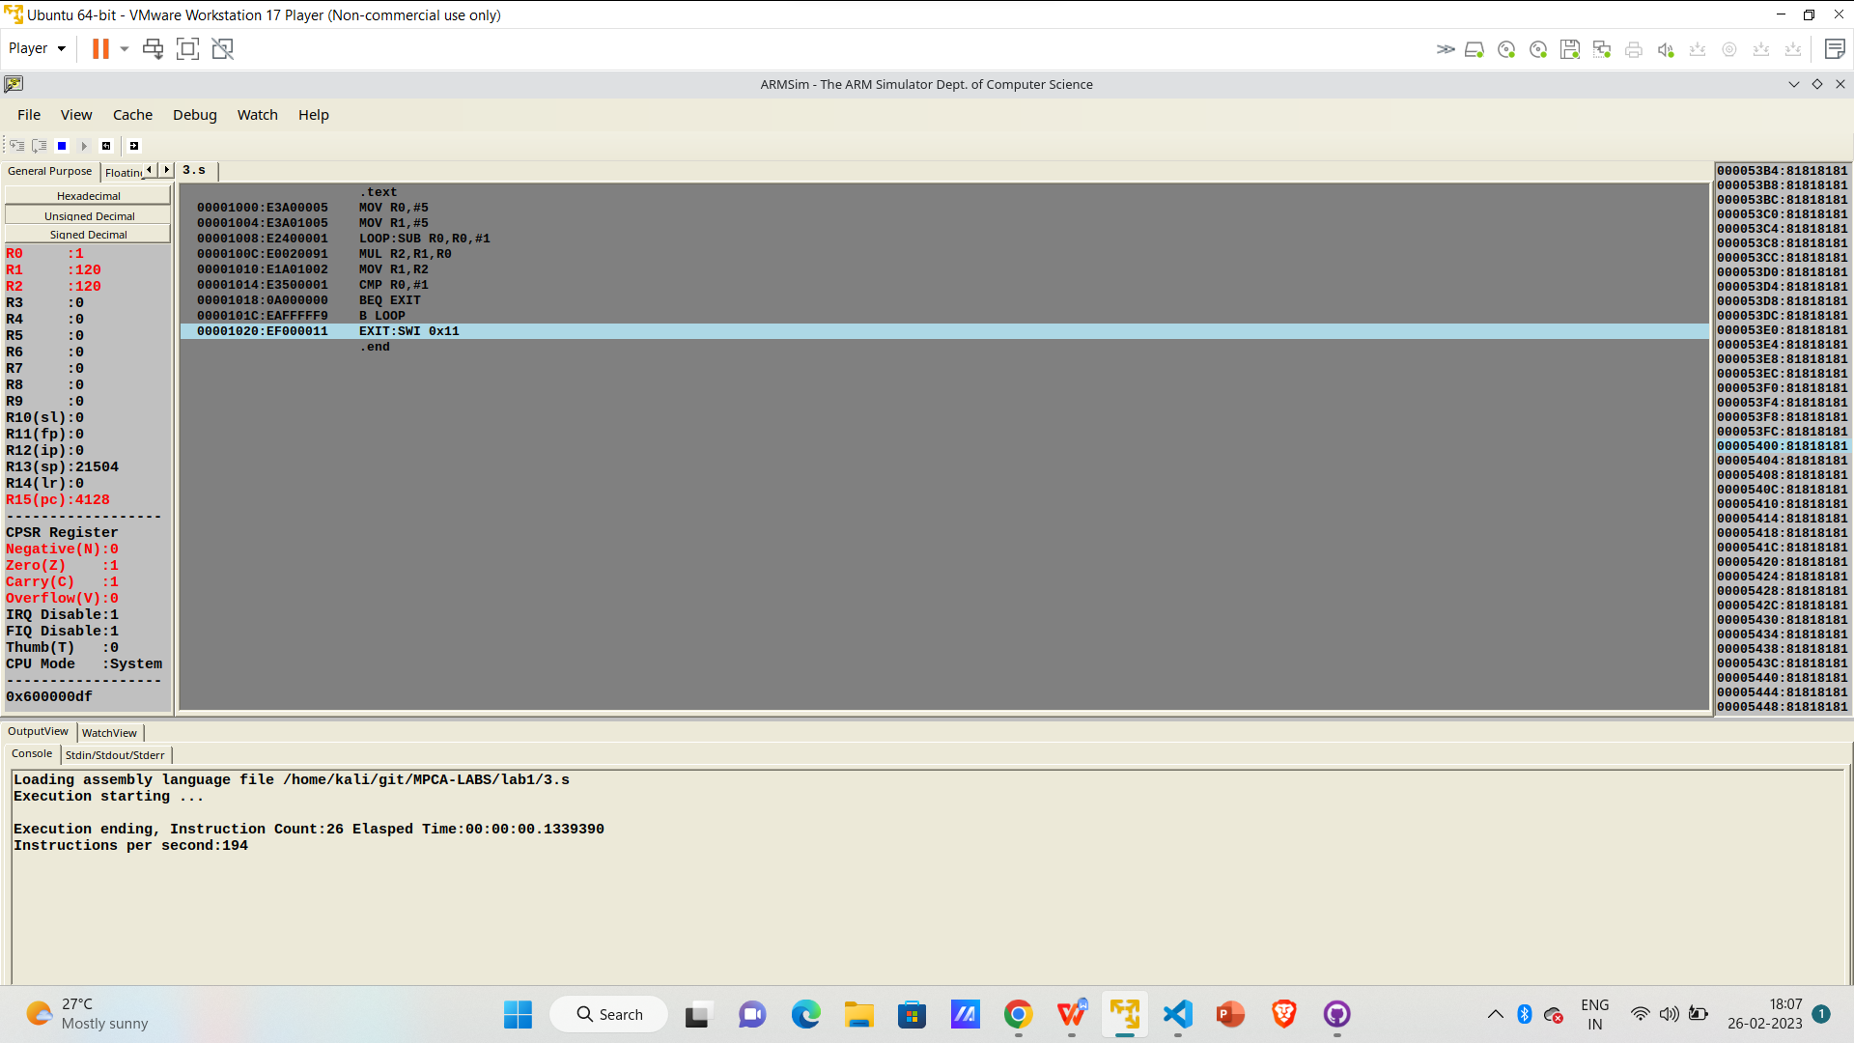

4. search for an element, sum of n elements in an array

using various addressing modes

.data

A: .word 5,10,15,20,25

.text

MOV R2,#15

MOV R3,#5

LDR R0,=A

MOV R4,#0

LOOP:

ADD r4, r4,#1

LDR R1,[R0],#4

CMP R1,R2

BEQ Label1

SUBS R3,R3,#1

BNE LOOP

BEQ NF

Label1:

MOV R7,R4

SWI 0x011

NF:

MOV R6,#-1

SWI 0x011

.end

